

Additional Learning Needs - ALN

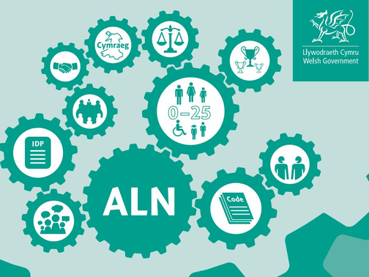

 G: Your right to request that the Local Authority reconsiders an IDP and takes over responsibility for maintaining it.

|  |  |  |
| --- | --- | --- |
| IndividualDevelopment Plans (IDPs)In most cases, your school will be responsible for writing and reviewing your IDP. In some circumstances, you are able to request the Local Authority to consider transferring your IDP over to become a Local Authority maintained IDP. | Local Authority Maintained IDPsIf you attend two schools, e.g. attend a pupil referral unit (PRU), Maes Derw, as well as your mainstream school or are Looked After by the Local Authority, then the Local Authority will become responsible for reviewing your learning needs and the support that you receive to help you make progress.When might a case be referred to the Local Authority for consideration· A school decides that a child or young person no longer has an Additional Learning Need (ALN) and the child or young person or their family are dissatisfied with this outcome.· A school thinks it is unable to provide the required additional learning provision the child or young person needs.· A child or young person needs advice and support from specialist services which the school cannot obtain.School request In most cases, your school will make a request to the Local Authority within 4 weeks of deciding that you have ALN.  When making a referral to the Local Authority, your school will tell you that is it doing so. | **Personal request** If you are unhappy with any decisions that your school makes about your learning or support, you have the right to request the Local Authority to reconsider your schools decision or the content of your IDP.Before doing this, it would be best to talk to your ALNCo or Headteacher at your school telling them about your concerns. If you are still unhappy you can request the Local Authority to reconsider your school’s decision.You have 4 weeks to make this request. This time begins from the moment your school notifies you of their decision.ALN Caseworkers Swansea Local Authority has a team of caseworkers who can provide you with advice and support if you are unhappy with a school’s decision.  If you think you will need support from this service speak to your ALNCo or Headteacher. Alternatively, you can email the caseworker team directly on: caseworker@swansea.gov.uk |